Platte Valley Mule Deer Recruitment Project
Carbon County Predatory Management District (CCPMD), USDA/APHIS/Wildlife Services (WS’), Wyoming Game and Fish department (WGFD), Wyoming Animal Damage Management Board (ADMB)
03/01/2013-07/01/2013
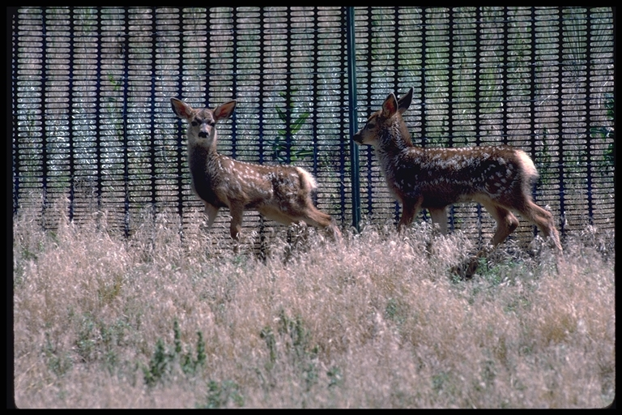
The Platte Valley Mule Deer Recruitment Project (PVMDRP) consists of a 3 yr. cooperative effort aimed at the removal of coyotes (Canis latrans) within the *Platte Valley Mule Deer Initiative (PVMDI) area. Specifically, removal efforts will take place within Wyoming Hunt Areas 78, 79, and 81. These removal efforts are aimed at increasing the viability of the mule deer (Odocoileus hemionus) herd fawning in these areas. The goal of the PVMDRP is that enhanced coyote removal will prove beneficial to mule deer fawn recruitment.
*http://wgfd.wyo.gov/web2011/wildlife-1000399.aspx
Work commenced in the removal areas on 03/01/2013 and continued until 07/01/2013. Efforts will continue annually through 2014 and 2015 as ADMB funding permits.
Specific ADMB funds received for the PVMDRP (2013) consisted of $10,000.00. These funds were spent on 4.6 hrs. rotor wing time and per diem ($3,793.80 Sky Aviation) and 39 hrs. fixed wing time and hazard duty ($6,206.20 WS) aerial hunting. Additionally, $19,252.78 was spent on the project for ground work, helicopter deer classification, and administrative work. This funding came cooperatively from CCPMD operational funds ($ 3,959.73), WS ($ 4,093.05) and WGFD ($11,200.00).
A total of 85 coyotes and 2 dens within 15 different WS cooperative agreements were taken from the project area. Of the 85 coyotes taken, 19 coyotes (16%) were retrieved for comprehensive data collection. 5 WS personnel were involved in project activities.
Comprehensive data from 19 coyotes verified for sampling and analysis below:
10 Adult Male Coyotes*
8 Adult Female Coyotes**
1 Juvenile Female Coyote
* 3 of the adult male coyotes exhibited the presence of Sarcoptic mange (Sarcoptes scabiei) mites.
**3 of the adult female coyotes exhibited signs of having whelped (7, 5, and 3 pups. (5 avg.). 1 of the adult female coyotes (5+ yrs-contained 3 unborn whelps).
Stomach content occurances of 19 coyotes verified for sampling and analysis below:
7 Pronghorn 9 rabbit/rodent 8 Livestock 1 bird
3 grass
The following contributing pages in sequence are:
- Map of PVMDRP removal area and provided GPS locations of coyotes taken. (WGFD and WS).
- Mule Deer survey report (WGFD, Will Schultz).

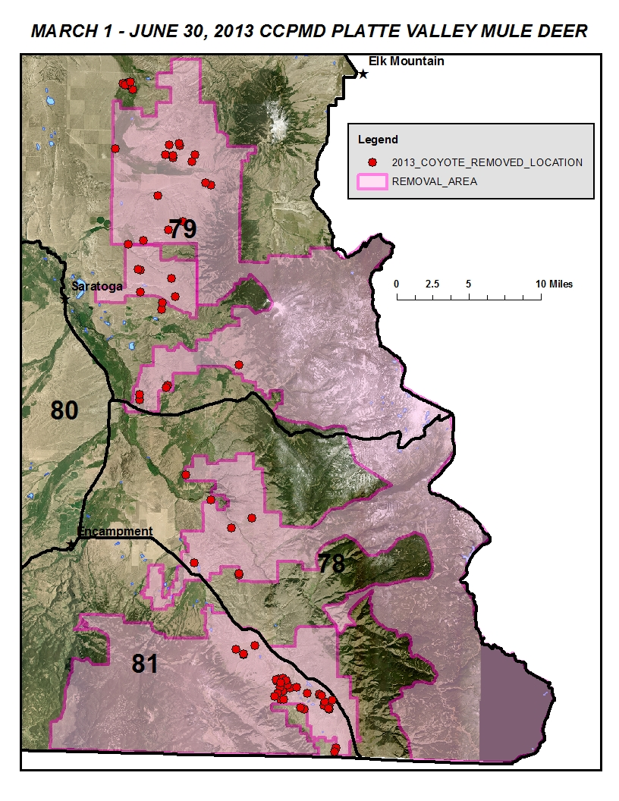

Postseason Classification Report
Wyoming Game and Fish Department conducts a postseason (December) helicopter survey annually in the Platte Valley mule deer herd unit. The annual fawn to doe ratio is determined from the survey’s data. Generally, mule deer populations are considered to require a fawn ratio of at least 65 fawns per 100 does in order to maintain population size. During the past ten years, the fawn ratio for the Platte Valley mule deer herd unit has only met or exceeded the 65 fawn per 100 does ratio during one year (Figure 1). A multitude of environmental factors are assumed to contribute the less than adequate ratios, including poor fawn recruitment due to predation.
In spite of the additional predator control efforts in the Platte Valley implemented in 2013, fawn ratios were lower than the previous year. The severe drought conditions experienced in this herd unit during 2012 left most mule deer entering the winter in very poor physical condition. We believe this factor may have resulted in less fawns being born in the spring of 2013. Therefore, the positive results of the additional predator removal efforts conducted in the Platte Valley may have been over-shadowed by less fawns being born in the first place during the spring of 2013. It is assumed that the observed fawn ratio would have been lower had the predator removal efforts not been implemented. Observations of mule deer numbers over the course of this 3-year project will provide for a more reliable indicator of the project’s success.
Figure 1. 2004-2013 Fawn ratios and goal for the Platte Valley mule deer herd unit, Wyoming.

There were 14 additional coyotes taken after 07/01/2013 due to continued efforts on the last year of a 3 year Pronghorn antelope recruitment project that overlapped the south end of the PVMDRP. Also, there were 31 additional coyotes for calander year 2013 that were taken in the PVMDRP before and after the ADMB project dates (03/01/2013-07/01/2013) in relation to livestock protection.
Very few mule deer were observed during the work on the project. It appears that the weather conditions during the last few years are impacting the population negatively. It is our hope that by removing coyotes in this area, the decrease in mule deer will be buffered by the reduced presence of coyotes available to prey on the deer population. Work in the PVMDRP will continue in 2014 with a $15,000.00 allocation from the ADMB and additional cooperative funding will continue from CCPMD and WS.
Reports for 2014 and 2015 to follow. If there are any questions please don’t hesitate to contact me. Thank you.

Sincerely,

Craig Acres
Staff Biologist USDA/APHIS/WS
Cc:Files

