Livestock Carcass Management Program
Progress Report for July 2013
Dusty Lasseter, Wyoming Game and Fish Department

Program Description: The Carcass Management Program (CMP) was started in June of 2008 with the purpose of removing livestock carcasses from private agricultural lands in order to minimize conflicts with grizzly bears and promote human safety.

Progress: From July 1, 2012 to June 30, 2013 (fiscal year) there have been 218 carcasses (in 112 trips) that have been retrieved from private ranch lands. Currently there are approximately 25-30 landowners participating in the CMP. The average monthly cost of the program for the last year was $1,343.08 giving an average cost per carcass $73.93. After the program started in 2008 there has been an increase of use and in early 2012 several new landowners have started utilizing the program which after seven months into 2013 we have already surpassed carcasses picked up in 2012 (Figure 1). Also, since the beginning of the CMP there have been several ranches close their carcass pits in order to reduce human-bear conflicts and in the last year several additional pits have been closed (see Figure 2.)

Month | Amount
July | $ 418.50
August | $ 594.00
September | $ 918.00
October | $ 1,228.50
November | $ 2,268.00
December | $ 567.00
January | $ 324.00
February | $ 918.00
March | $ 1,012.50
April | $ 1,039.50
May | $ 2,835.00
June | $ 2,794.50
Net Total | $ 14,917.00
Landfill Costs | $ 1,200.00
Total | $ 16,117.00

Table 1. Figure 1.

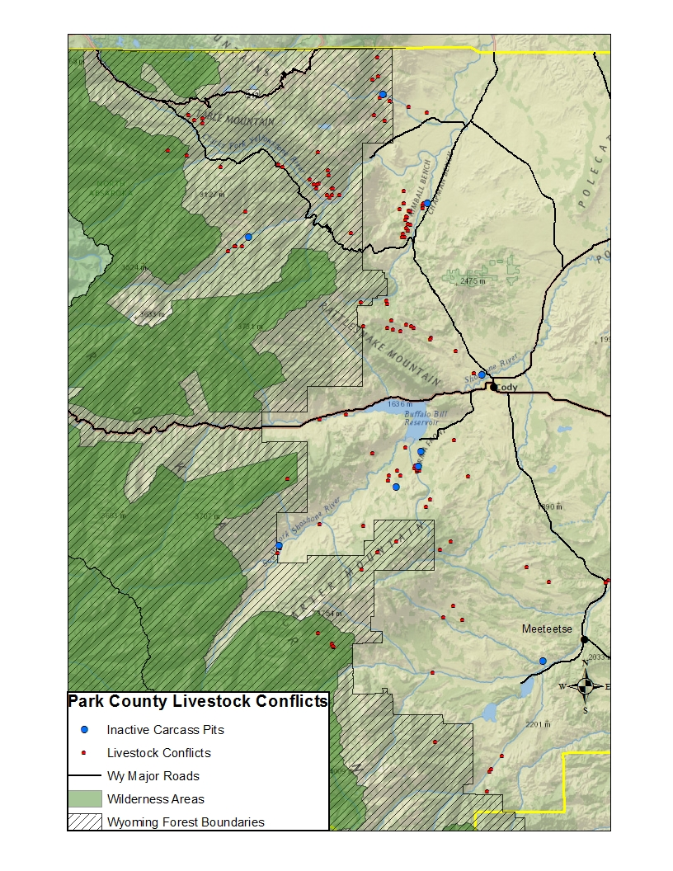

Figure 2.

